Digital Forensics Report

1 Introduction
The purpose of this report is to provide corroborative evidence to illegal hacking practices including but not limited to hacking software, evidence of their use, and any data that might have been generated, and tie the computer to the suspect, Greg Schardt. The facts presented in this report are those within the preparer’s own area of expertise and knowledge and do not extend to matters and knowledge outside of such expertise.

2 Forensic Examination

2.1 Tools

AUTOPSY
Autopsy was the software used for analyzing digital data found in a disk image generated from the Dell CPi Notebook Computer, serial # VLQLW. Autopsy is an open source digital forensics software which provides investigators with the tools to conduct complex investigations with accuracy and efficiency. Autopsy provides the ability to manage large volumes of computer evidence and view computer drive contents including files, operating system artifacts, file system artifacts, and deleted files or file fragments located in file slack or unallocated space. To the expert’s knowledge, there is no software in use above that possesses any material issues whose severity would invalidate the findings thereof.

2.2 Evidence Classes

Evidence Class | Description
1 | Hacking software
2 | Evidence of use of hacking software
3 | Data generated by use of hacking software
4 | Connection between computer and suspect

2.2.1 Evidence Class 1 - Hacking Software

The following hacking software was found:

- NetCat
Netcat is a featured networking utility which reads and writes data across network connections, using the TCP/IP protocol.
It is designed to be a reliable "back-end" tool that can be used directly or easily driven by other programs and scripts. At the same time, it is a feature-rich network debugging and exploration tool, since it can create almost any kind of connection you would need and has several interesting built-in capabilities
Exhibit A - screenshot of NetCat program files installed in Schardt’s computer.

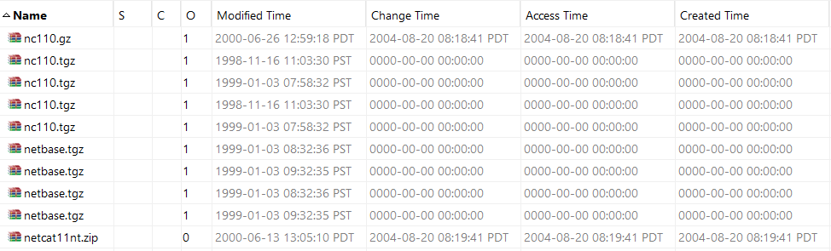

- John The Ripper
John The Ripper is a password cracker, currently available for UNIX, DOS, WinNT / Win95. Its primary purpose is to detect weak UNIX passwords.

Exhibit B - screenshot of John The Ripper program files installed in Schardt’s computer.
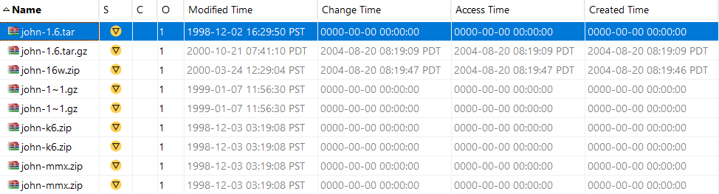

- Brutus
Brutus is an online or remote password cracker. It is a remote interactive authentication agent. Brutus is used to recover valid access tokens (usually a username and password) for a given target system. Examples of a supported target system might be an FTP server, a password protected web page, a router console a POP3 server, etc.

Exhibit C - screenshot of Brutus program files installed in Schardt’s computer.

- Cain & Abel
A windows-only password recovery handles an enormous variety of tasks. It can recover passwords by sniffing the network, cracking encrypted passwords.

- Ethereal
A packet sniffer, an application that can capture all packets sent through a network to then interpret them and see what tasks are being carried out on the network.

- 123 Write All Stored Passwords
A program that reads the Windows .PWL file and tells you all the stored Windows user passwords.

- Anonymizer
A tool that masks your IP address and location, making it harder for websites to track your activities and identify you. It works by routing your internet traffic through a proxy server, which then forwards your requests to the destination website anonymously.

- Look@LAN
A network discovery tool.

- NetStumbler - wireless access point discovery tool
Netstumbler.com offers freeware written by Marius Miner that allows anyone with an 802.11b wireless LAN access card to detect and analyze wireless LANs. The software is known for its ability to identify open wireless access points, known as "wardriving," and is useful for verifying network setups, finding coverage issues, and detecting interference. Although it is not open-source, Netstumbler is free to download and requires Windows 2000, XP, or newer operating systems.

- CuteFTP - FTP software

Exhibit D - screenshot of installed programs in Schardt’s computer including: Cain & Abel, Ethereal, 123 Write All Store Passwords, Anonymizer, Look@LAN and NetStumbler, CuteFTP.

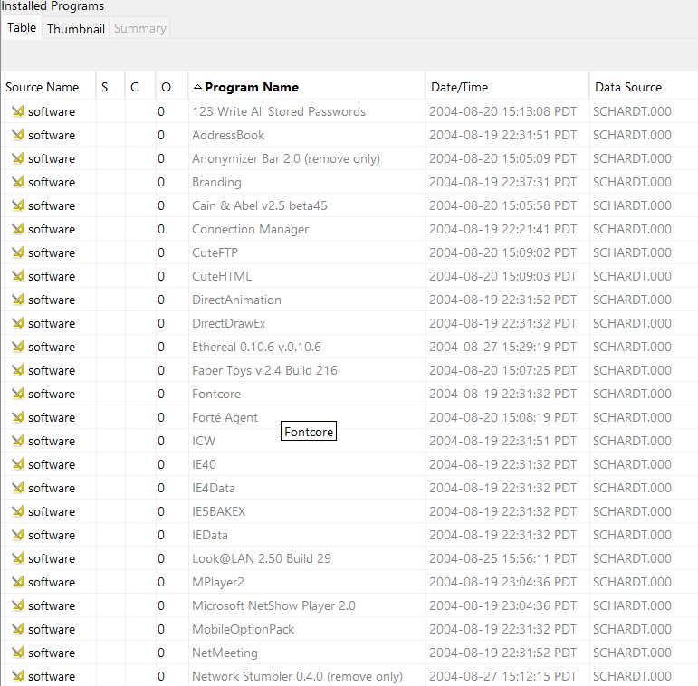

2.2.2 Evidence Class 2 - Evidence of use of hacking software

The following screenshots display the use of the following hacking software found in Mr. Schardt’s computer including Brutus, John The Ripper and NetCat.

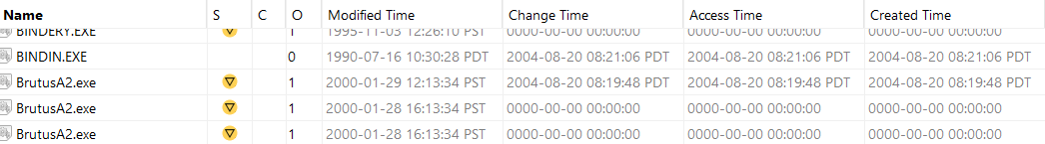

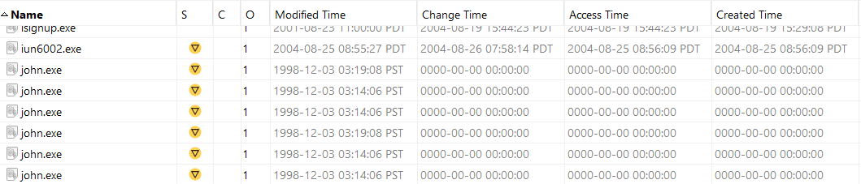

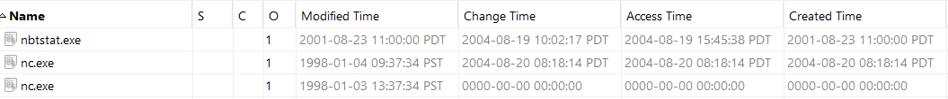

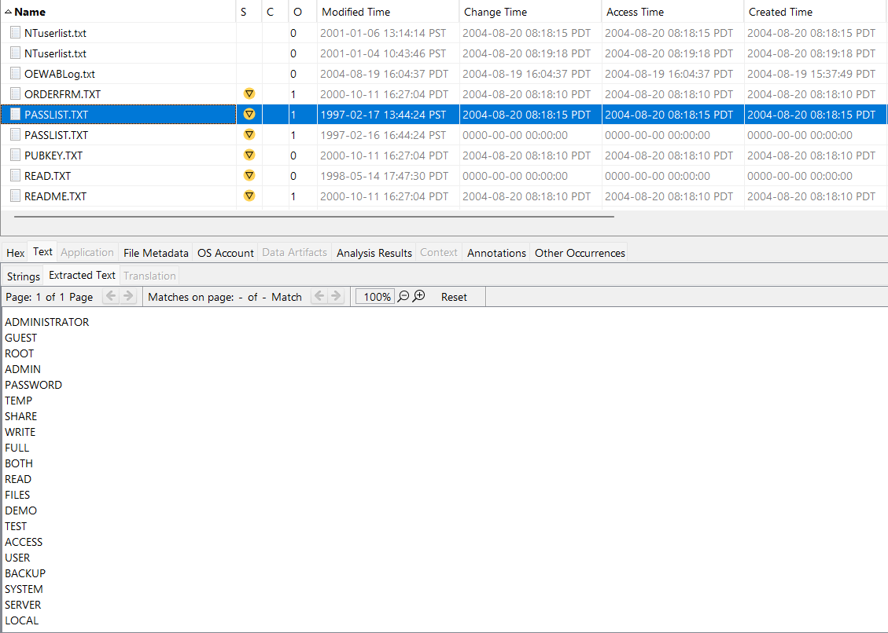

2.2.3 Evidence Class 3 - Data generated by use of hacking software

Under Mr. Evil’s documents, the following files were found containing dictionary lists of passwords that may have been used to perform Brute Force cyber attacks when trying to crack target systems’ end user passwords.

- pocket-dic.gz
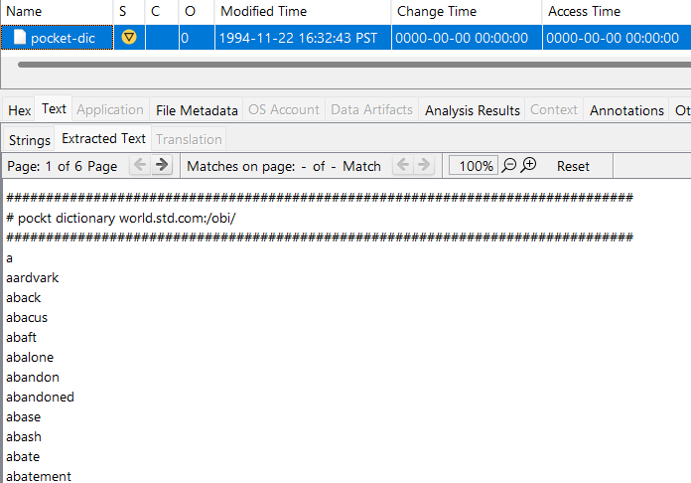

- Unix.dict.gz
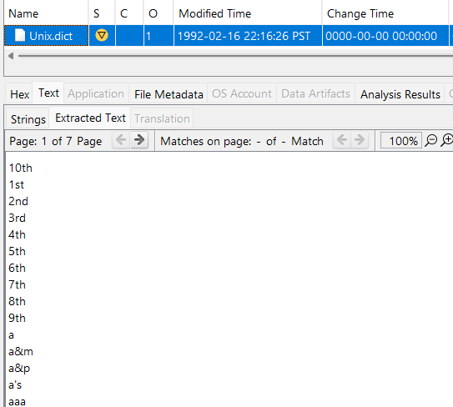

- Words-english.gz
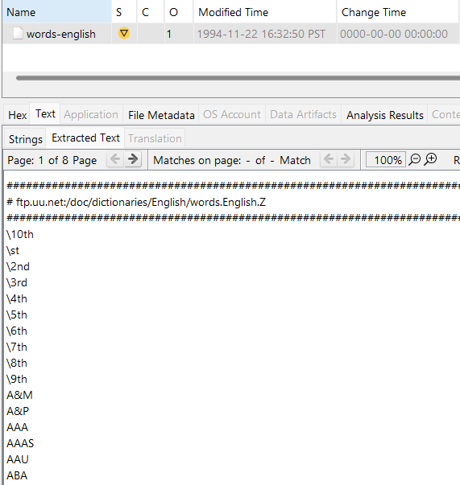

- USERLIST.txt

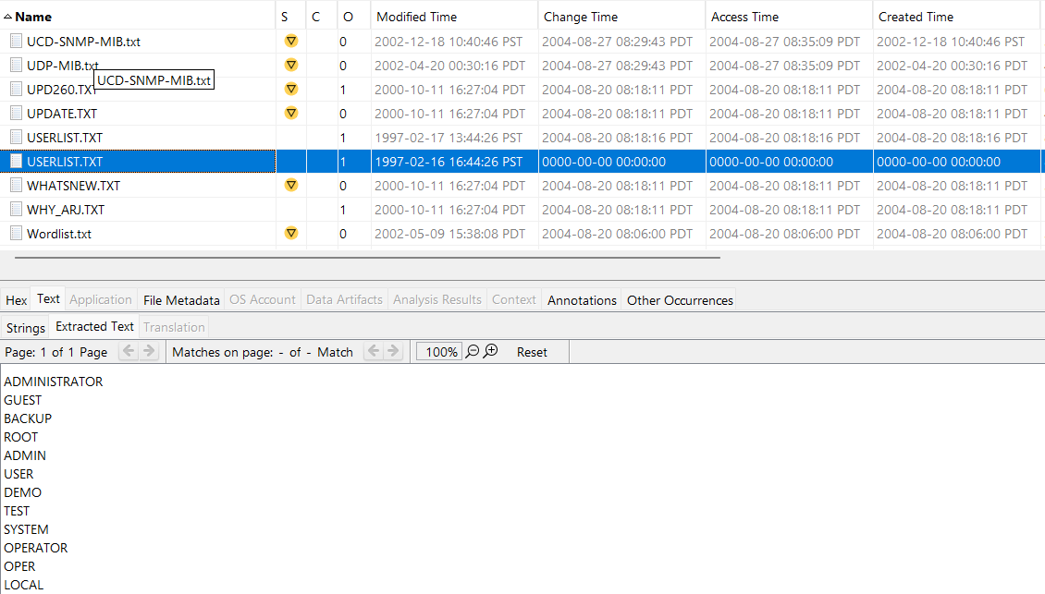
2.2.4 Evidence Class 4 - Connection between computer and suspect

The following screenshot shows the Microsoft Windows XP license owner as Greg Schardt. This piece of evidence connects Mr. Greg Schardt to the Dell CPi notebook computer.

Exhibit - Screenshot of Mr. Shcardt’s computer license information.

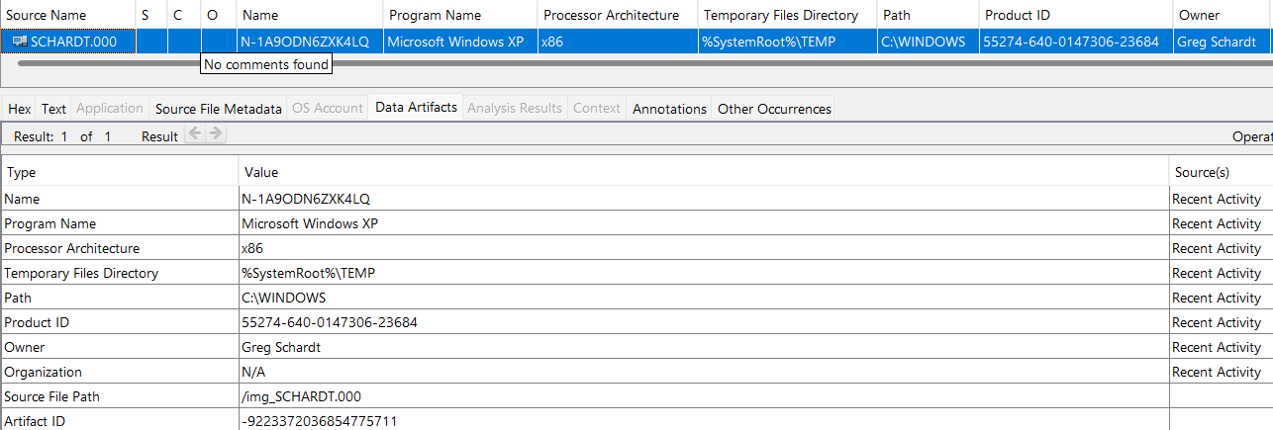

2.3 ANALYSIS & CONCLUSION

The above evidence found in Mr. Schardt’s computer demonstrates the presence and use of hacking software pertaining to intercepting internet traffic. Based on our findings pertaining to the computer’s Operating System license, we can attest that the computer that was confiscated (Dell CPi notebook computer, serial # VLQLW) was indeed Mr. Schardt’s. Although no stolen personal information was found, the presence of CuteFTP indicates that there could be other files relevant to the investigation if such software could be accessed.

In conclusion, based on our findings, we believe that Mr. Shchardt was breaking the law by illegally attempting to connect to weak Wi-Fi connections by the use of brute force attacks; however, no evidence was found pertaining to stealing credit card numbers or other personal information.

